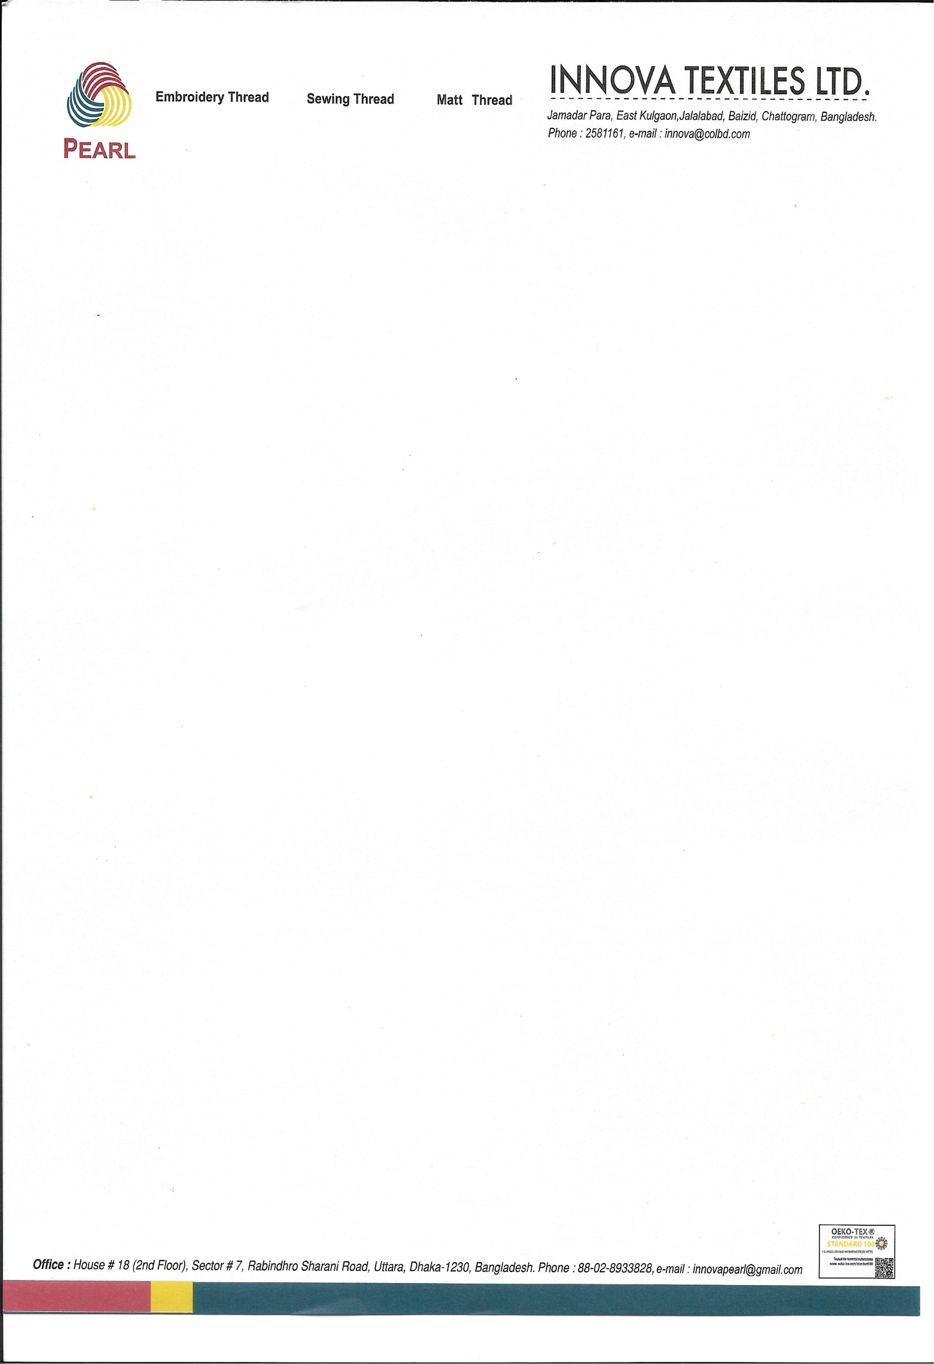

May 22, 2026

To Whom It May Concern

This is to certify that Mr. Khondoker Sadi Mahamud, son of Khondoker Mohiuddin, is currently employed as a Welfare & Community Engagement Executive at Innova Textiles Ltd. He joined the organization on October 7, 2020, and continues to serve in this position with dedication and professionalism.
In his current role, Mr. Mahamud plays a key role in designing and implementing employee well-being programs, community outreach initiatives, and social development activities across the factory premises. He consistently demonstrates sincerity, honesty, and commitment in carrying out his responsibilities. He is hardworking, professional, and possesses strong work ethics along with excellent operational knowledge. His pleasant personality and commendable character have made him a valued member of our team.
Mr. Mahamud currently receives a monthly salary of BDT 30,000 (Bangladeshi Taka Thirty Thousand Only), which is paid in cash in accordance with company policy.
We appreciate his valuable contributions to the organization and are confident that he will continue to excel in his professional endeavors.




S.M. Nasir Uddin
Director
Cell: +880 1730055510
E-mail: nasir.uddin@innovatextiles.co

